



AKD TimbersmartOne

User Manual Yarram

**Purchase AKD Colac packs & Receipt to Yarram**

# Purchasing

## Purchase AKD Colac packs & Receipt to Yarram

### Overview – Manual Method

|  |
| --- |
| Yarram purchases some products from Colac as infeed packs for further processing. Initially these products will be Paling line infeed: FLITCHUTGBS10004148 (Colac product code MERUTGBS1004048) and FLITCHUTGBS10004154 (Colac product code MERUTGBS1004054).   1. YARRAM creates Purchase Order against AKD Timber Trading   <Orders><Purchase Orders> |
| Email or send PO to AKD Colac |
| 1. COLAC raises Sales Order using the Yarram PO as reference number |
| Products manually changed on SO to match Colac site product codes |
| Packs and Despatch Docket sent to Yarram |
| 1. YARRAM enters received packs via <Receipting / EDI>< Receipting / EDI> as per Despatch Docket using the Despatch Docket number as the Run reference |
| Reconcile Despatch Docket with Pack Receipt Detail report |
| Post the receipted packs using Colac pack numbers |
| 1. YARRAM - Setup default Process_Product_Destination for traded products (this has already been done for FLITCHUTGBS1004148 & FLITCHUTGBS1004154) |

### 1. YARRAM Creates Purchase Order

In <Main Menu><Purchase Orders> click the **New** button to create a new PO.

In the Purchase Order Header tab:

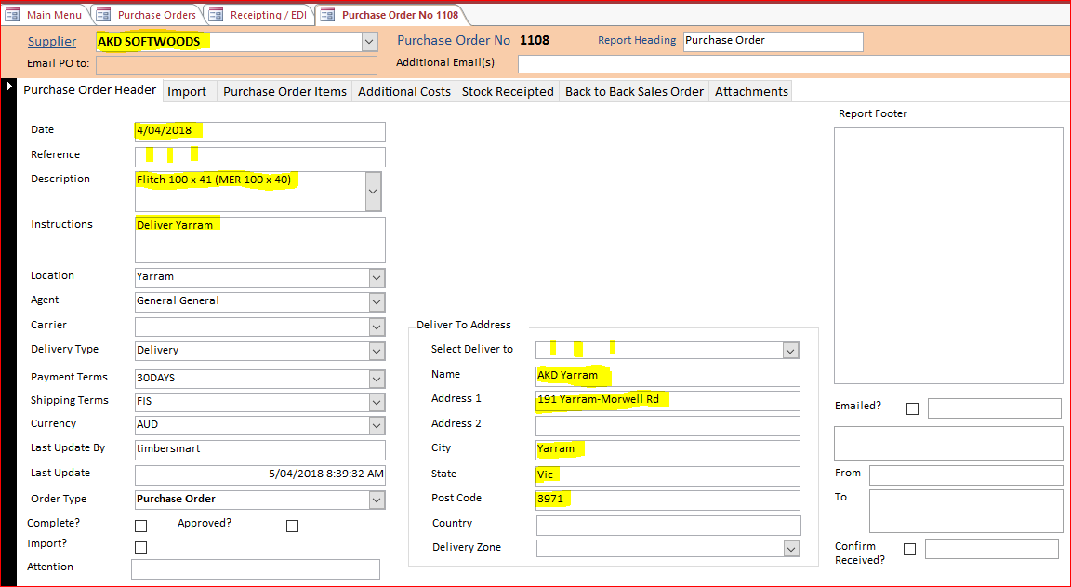

**4**

**3**

**2**

**1**

1. Select the supplier from the drop-down.
2. Change or accept the default date, and enter Reference, Description and Instructions as required.
3. **Select Deliver to** from the drop down, or enter the delivery address details.
4. Click the **Purchase Order Items** tab to enter the required products. A new PO number is assigned at this point.

For each product:

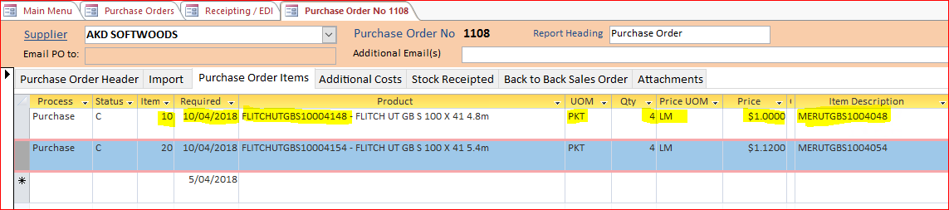

**1**

1. Enter the **Item** number. Change or accept the **Required** date. Start typing the **Product** code or select from the drop-down. Select **UOM**. Enter the **Qty** and **Price**. Optionally enter the corresponding Colac product code in the **Item Description**, or leave blank to accept the description of the Yarram product in this field. Press <F9> to save the line item.
2. Click the **Preview** button at top right to see a preview of the PO.

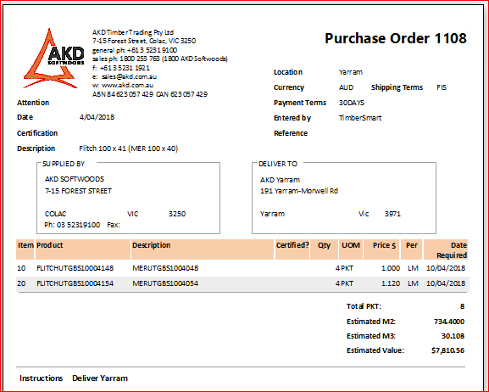

1. Email or send the PO to AKD Colac

### 2. COLAC raises Sales Order using the Yarram PO as reference number

### 3. YARRAM enters received packs

Select <Main Menu><Receipting / EDI><Receipting / EDI>

In the Header section of the screen:

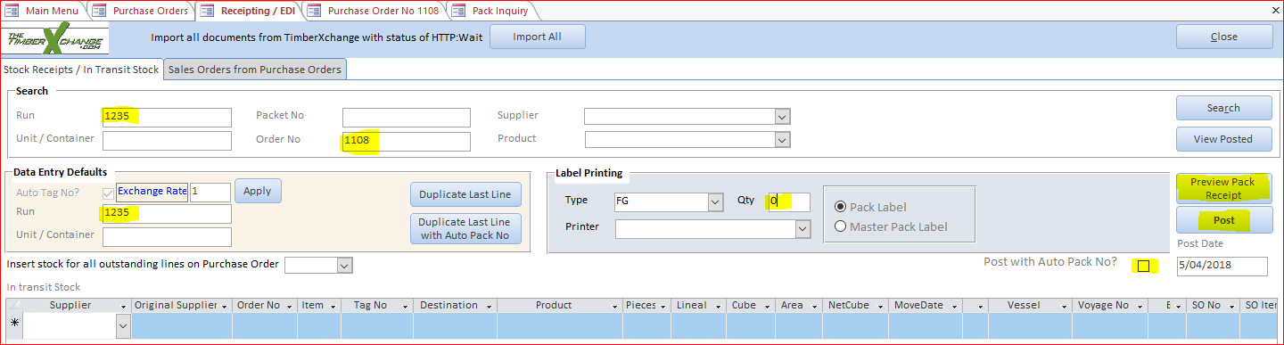

**3**

**2**

**1**

1. In the **Search** box at top of screen enter the Despatch Docket number in the **Run** field, and the Purchase Order number In the **Order No** field.
2. To retain the Colac pack numbers and NOT print a replacement label enter ‘0’ in the **Qty** field In the **Label Printing** box, and un-check **Post with Auto Pack No?.**
3. Optional: If the packs to be received have sequential Colac pack numbers you can enter the Despatch Docket number in the **Run** field in the **Data Entry Defaults** box. After receipting the first pack, click **Duplicate Last Line** to receipt the next pack with the Tag No (pack number) incremented by 1.

In the Line Items section of the screen:

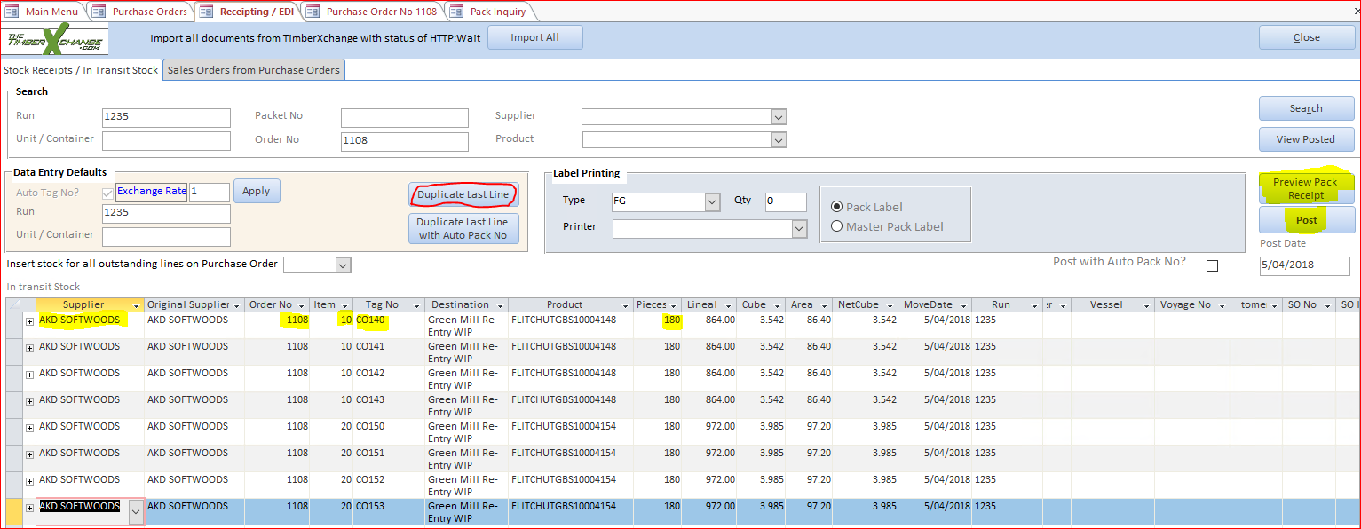

**9**

**7**

**6**

**5**

**4**

**8**

1. Enter the **Supplier** or select from the drop-down. Enter the **Order No** or select from the drop-down.
2. Enter the **Item** or select from the drop-down. The **Destination** and **Product** will be automatically filled.
3. Enter the **Tag No** and **Pieces**. The Lineal, Cube, Area, NetCube will be calculated. Run will be filled. Press <F9> to save the record.
4. Continue receipting packs per line as above, or click **Duplicate Last Line** if receipting sequential pack numbers.
5. When receipting is complete click **Preview Pack Receipt** before Posting.

Crosscheck the received Delivery Docket against the packs receipted as shown in this Pack Receipt Detail report before Posting. Use this to reconcile packs physically received compared to packs listed on the Delivery Docket. This document then can go to financials to match off against the supplier invoice

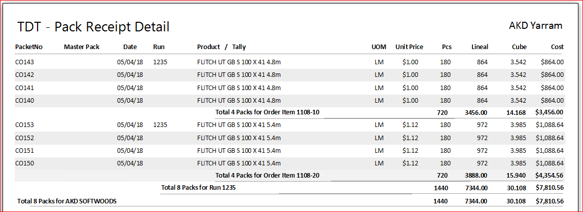

1. Click **Post** to post the packs to stock.
2. Confirm that you want to post. A message will confirm ‘Successfully Posted Packs’.